Bat and Moth Walk on Sunday 30th July 2017
Our thanks to Bill Welch who was responsible for trapping and identifying the moths on this very well-attended event. He has sent us this report and photographs taken at the site. He has also supplied a spreadsheet showing the names of the moths and their larval food plants which can be found on the Wildlife page.
"There were 27 moths of 13 species, quite good for a short period of trapping with a low-powered trap. Nothing out of the ordinary arrived, in fact most of the food plants were within arm's reach. The little Straw Grass-veneer on a grass stem I photographed before I set the trap. There were dozens of them in the grass, easily disturbed by a walker. All the others were photographed in or on the trap."

The Moths
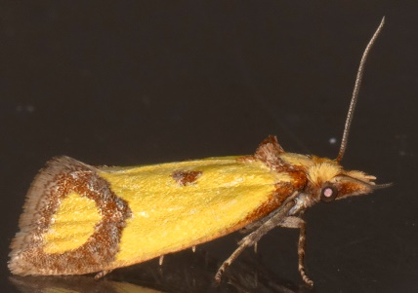 | 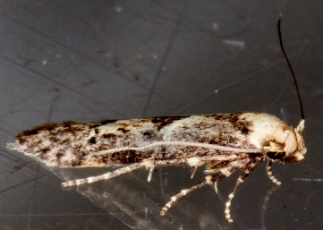 |  | 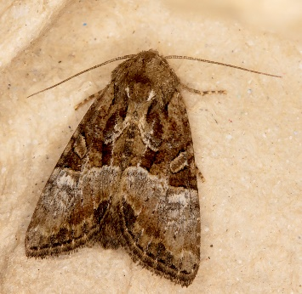
Agapeta zoegana | Blastobasis adustella |  | Cloaked minor
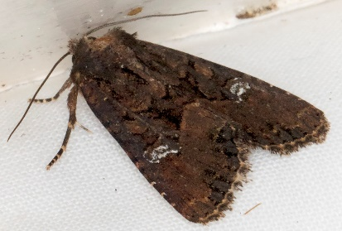 | 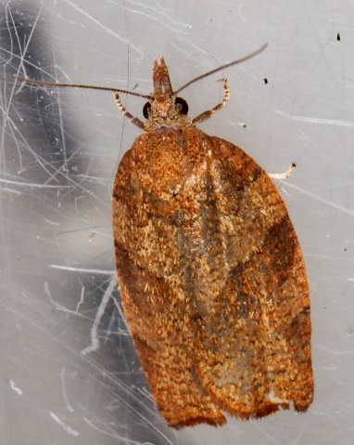 |  | 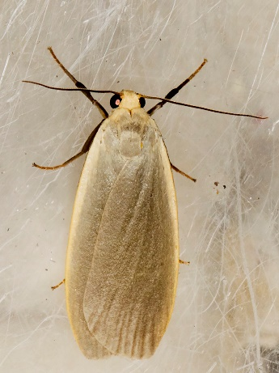
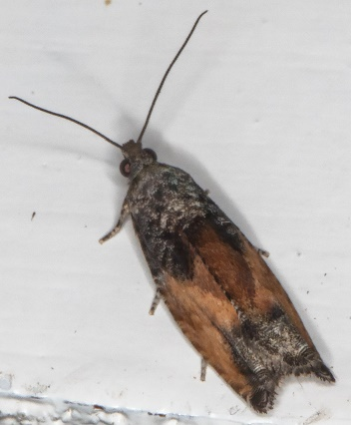 |  | 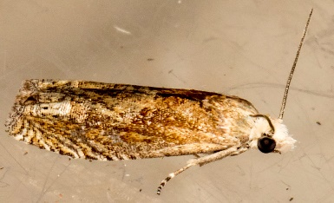 |  | 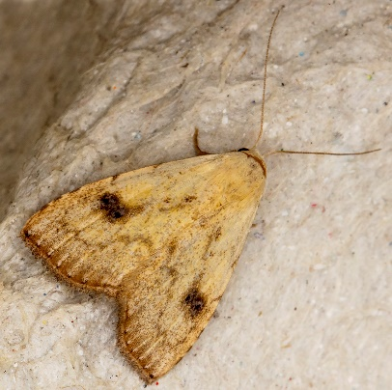
Epinotia nisella |  | Eucosma hohenwartiana |  | Straw Dot
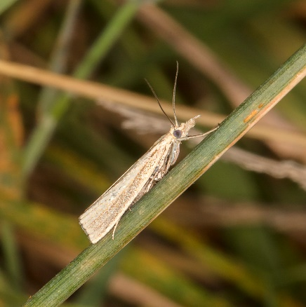 |  | 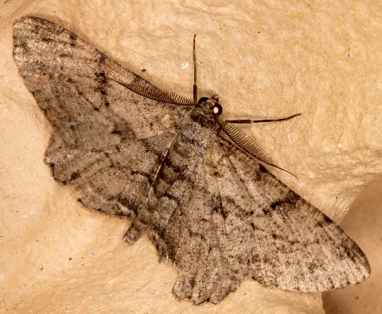 |  | 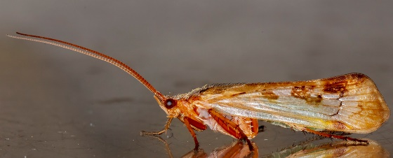
Straw Grass-veneer |  | Willow Beauty |  | caddis fly - unknown type

The Trap
"The trap was a Skinner type with a 15 watt actinic bulb, which gives off most of its light in the ultra-violet. The construction is extremely simple and the whole setup, including a battery good enough to power it all night if necessary, folds down into a bag I can carry in one hand. (It is quite heavy, though.) The other bag in the photo of the trap contained a couple of moth books. And I carry my camera in a shoulder-bag."
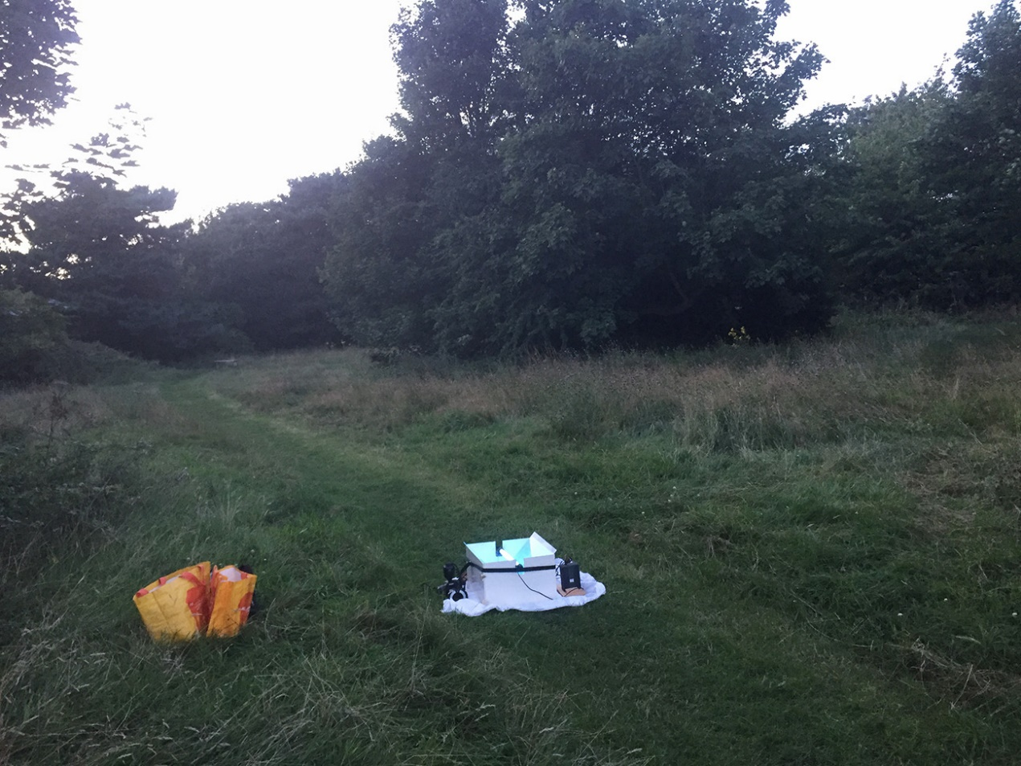
By Bill Welch

